**Implementing CRM for Result Tracking of a Candidate with Internal Marks**

**Task 1**

**Project Specifications**

[Understanding the Need for Implementing CRM]

**1.1 Introduction:**

"Implementing a CRM in Salesforce for Result Tracking of Candidates with Internal Marks" represents a comprehensive solution designed to transform the way candidate results are recorded, tracked, and managed.

**1.2 Project Goals:**

* + Streamline and modernize the process of tracking and managing candidate results, with a specific focus on internal marks.
  + Enhance data accuracy and reliability by minimizing manual data entry and human errors.
  + Improve accessibility to result tracking data for educational institutions, recruitment agencies, and HR departments.

**1.3 Problem Definition & Design Thinking**

**Empathy Map:**

Understanding the needs and pain points of users, including educators, HR professionals, and administrators, to create a user-focused system.

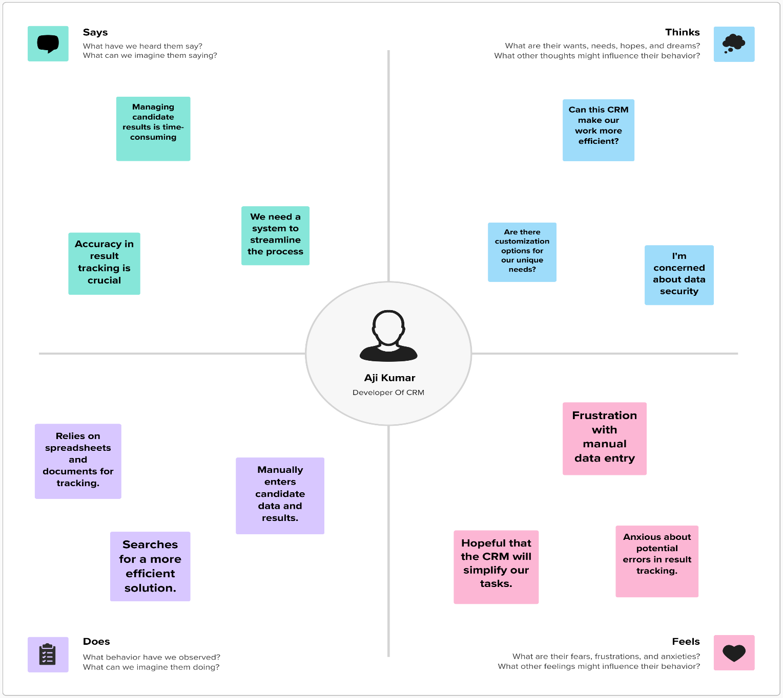

**Ideation & Brainstorming:**

Generating creative solutions to address the identified challenges, using brainstorming and collaboration.

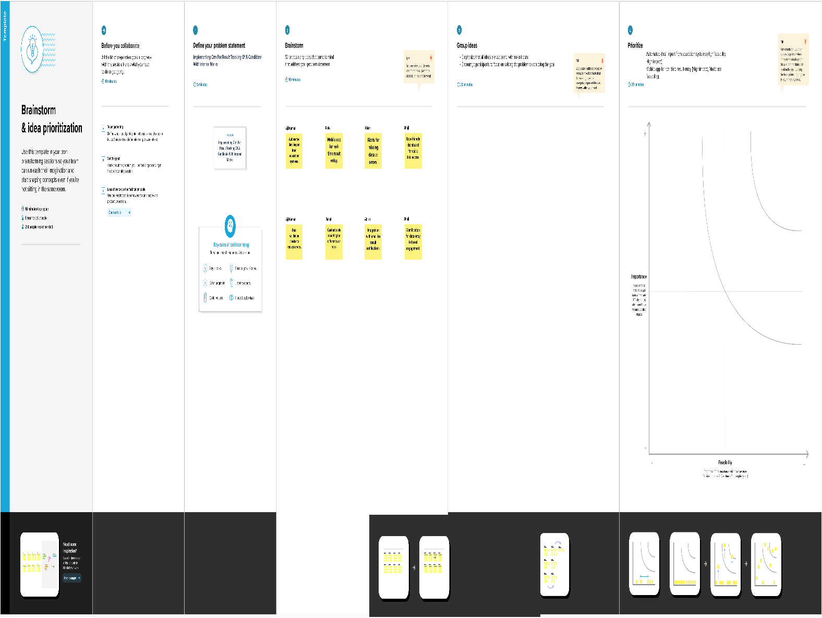

**1.4 Scope:**

* Creation of a comprehensive CRM system in Salesforce.
* Automation of data entry, processing, and result tracking.
* User-friendly dashboard for real-time data access.

**1.5 Technical Requirements:**

Technology Stack: Salesforce CRM, database management systems.

Hardware: Servers and storage for Salesforce instance.

Software: Salesforce licenses, custom development tools.

**1.6 Functional Requirements:**

User Roles: Define user roles and permissions for educators, administrators, and HR professionals.

Data Entry: Implement user-friendly data entry forms for candidate result tracking.

Reporting: Create customizable reports and dashboards for data analysis.

Automation: Implement workflows and triggers for automated processes.

Customization: Allow for customization of fields and layouts to accommodate various needs.

**Task 2**

**Preparation Data Modeling:**

[Understanding the objects and relationship between them]

**Creating Custom Object**

Object Name – Semester

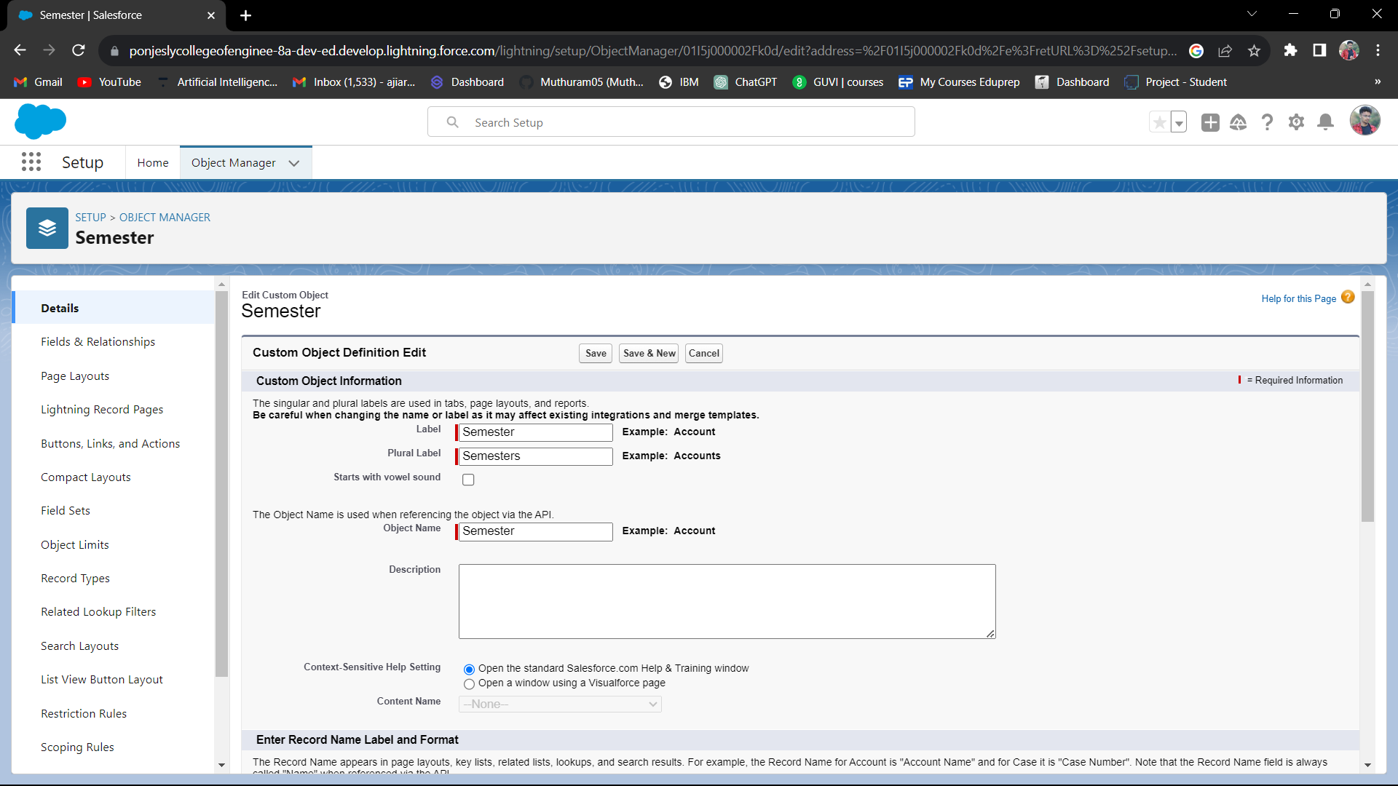

Object Name- Candidate

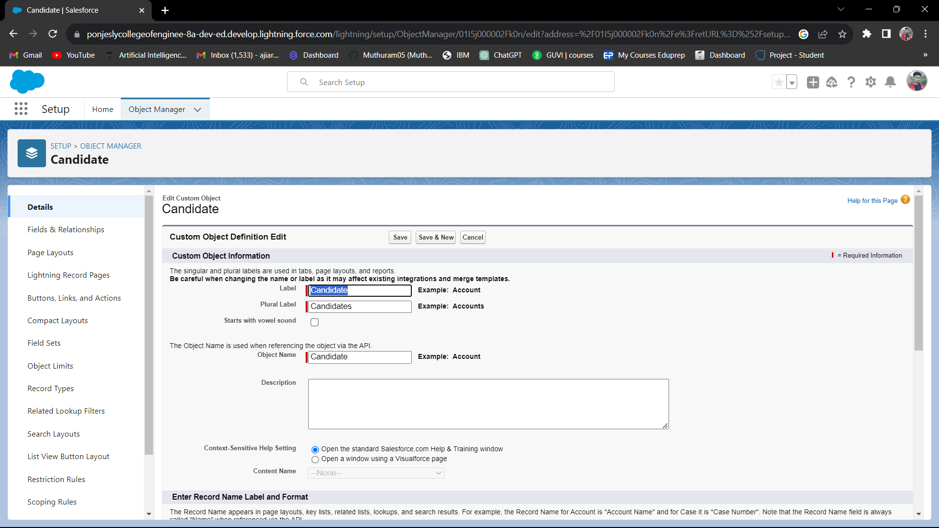

Object Name – Course Detail

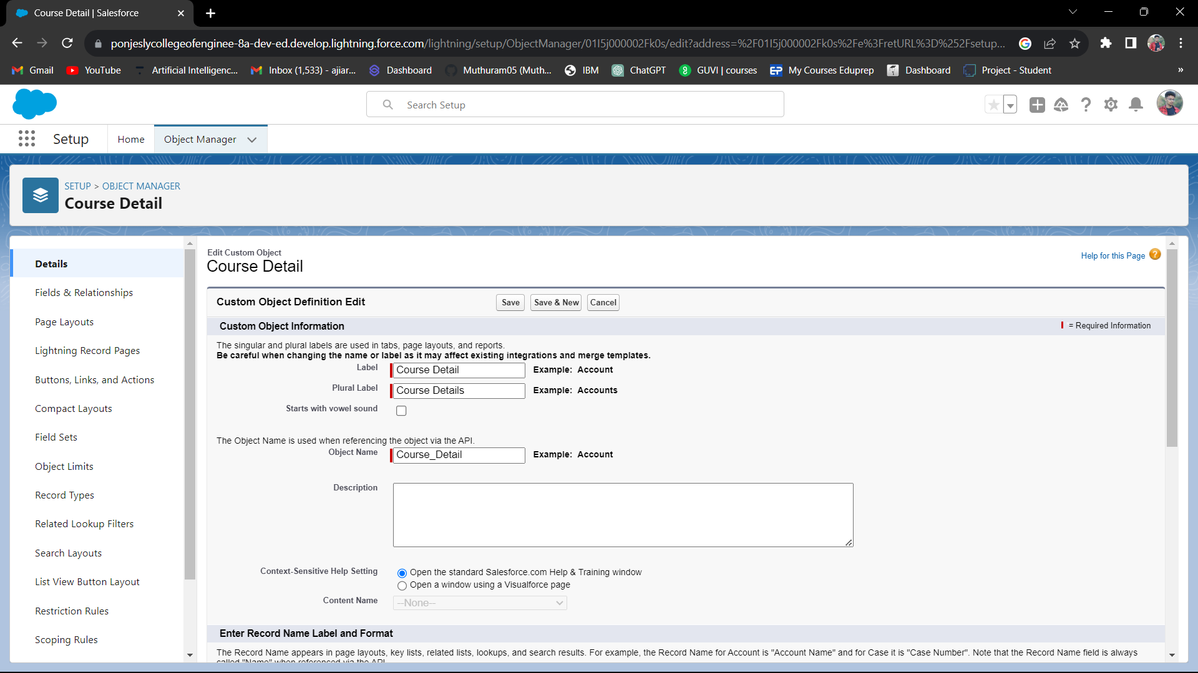

Object Name – Lecturer Detail

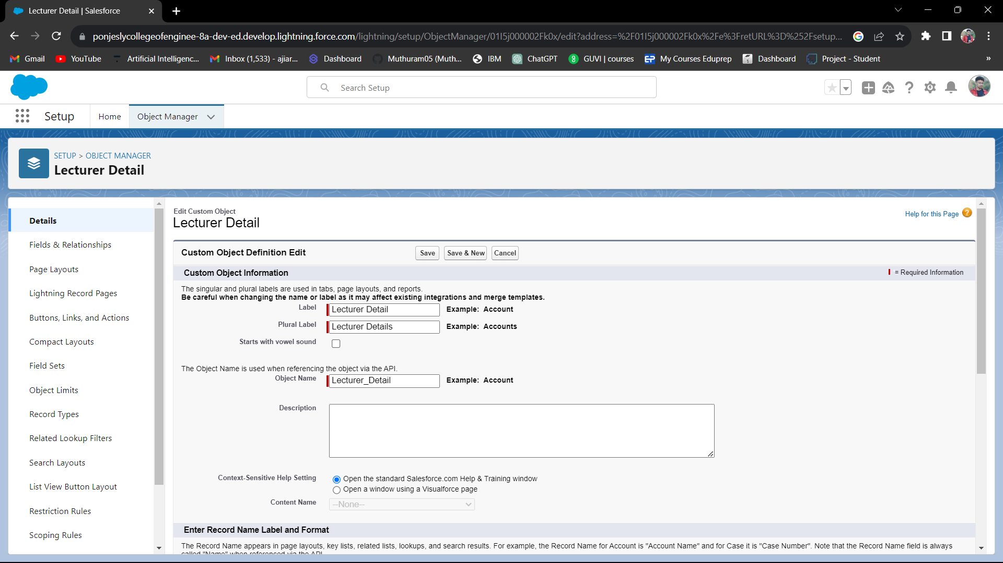

Object Name – Internal Result

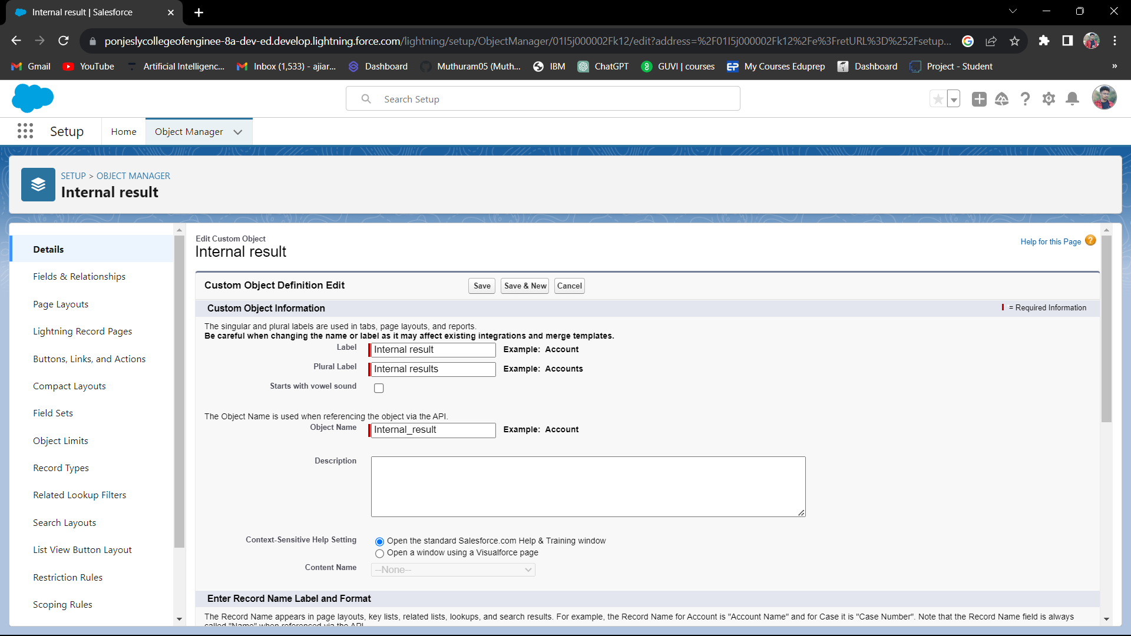

**Creating Object Fields & Relationships:**

Semester and Candidate Relationships

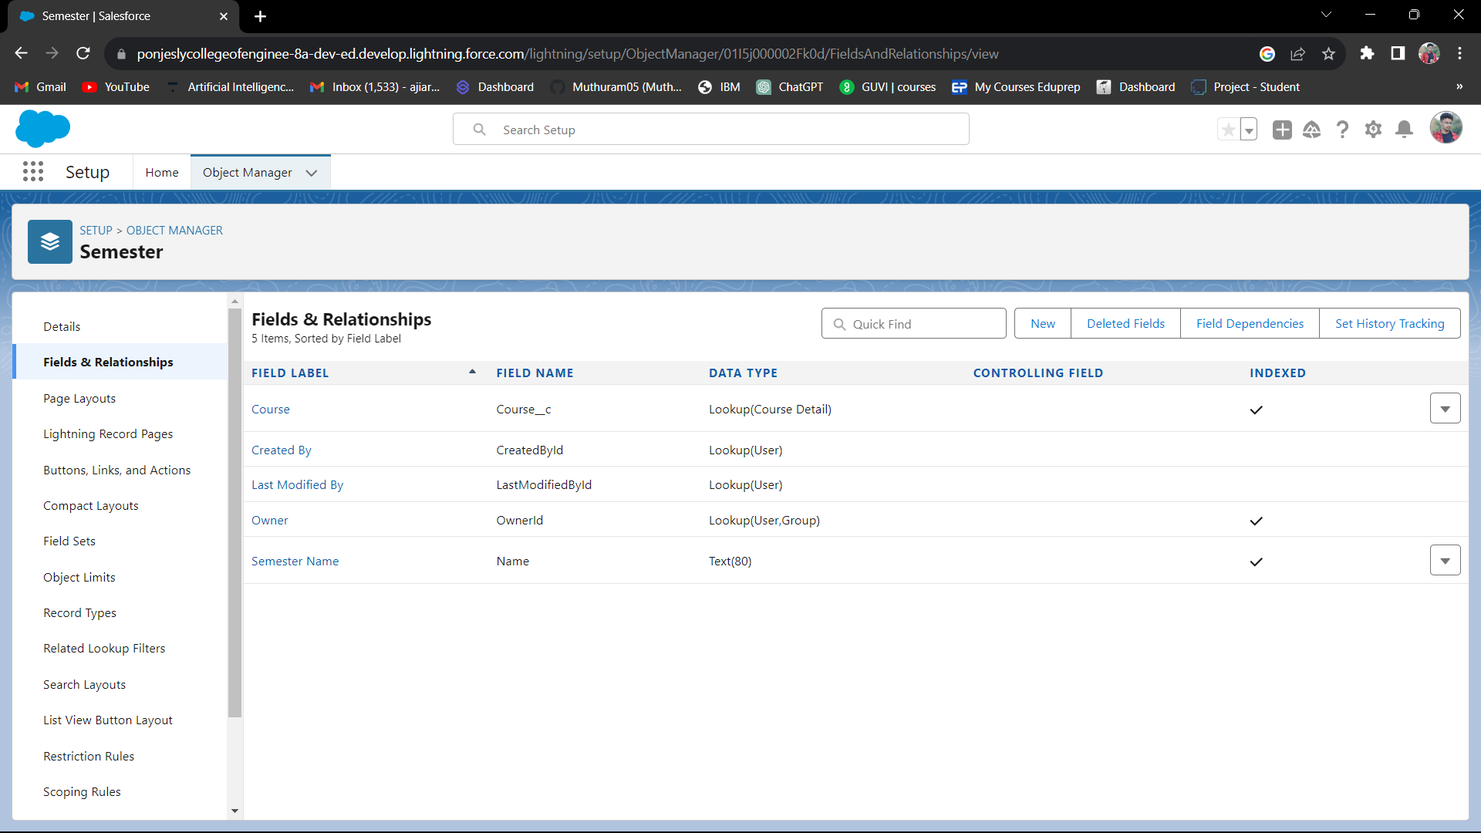

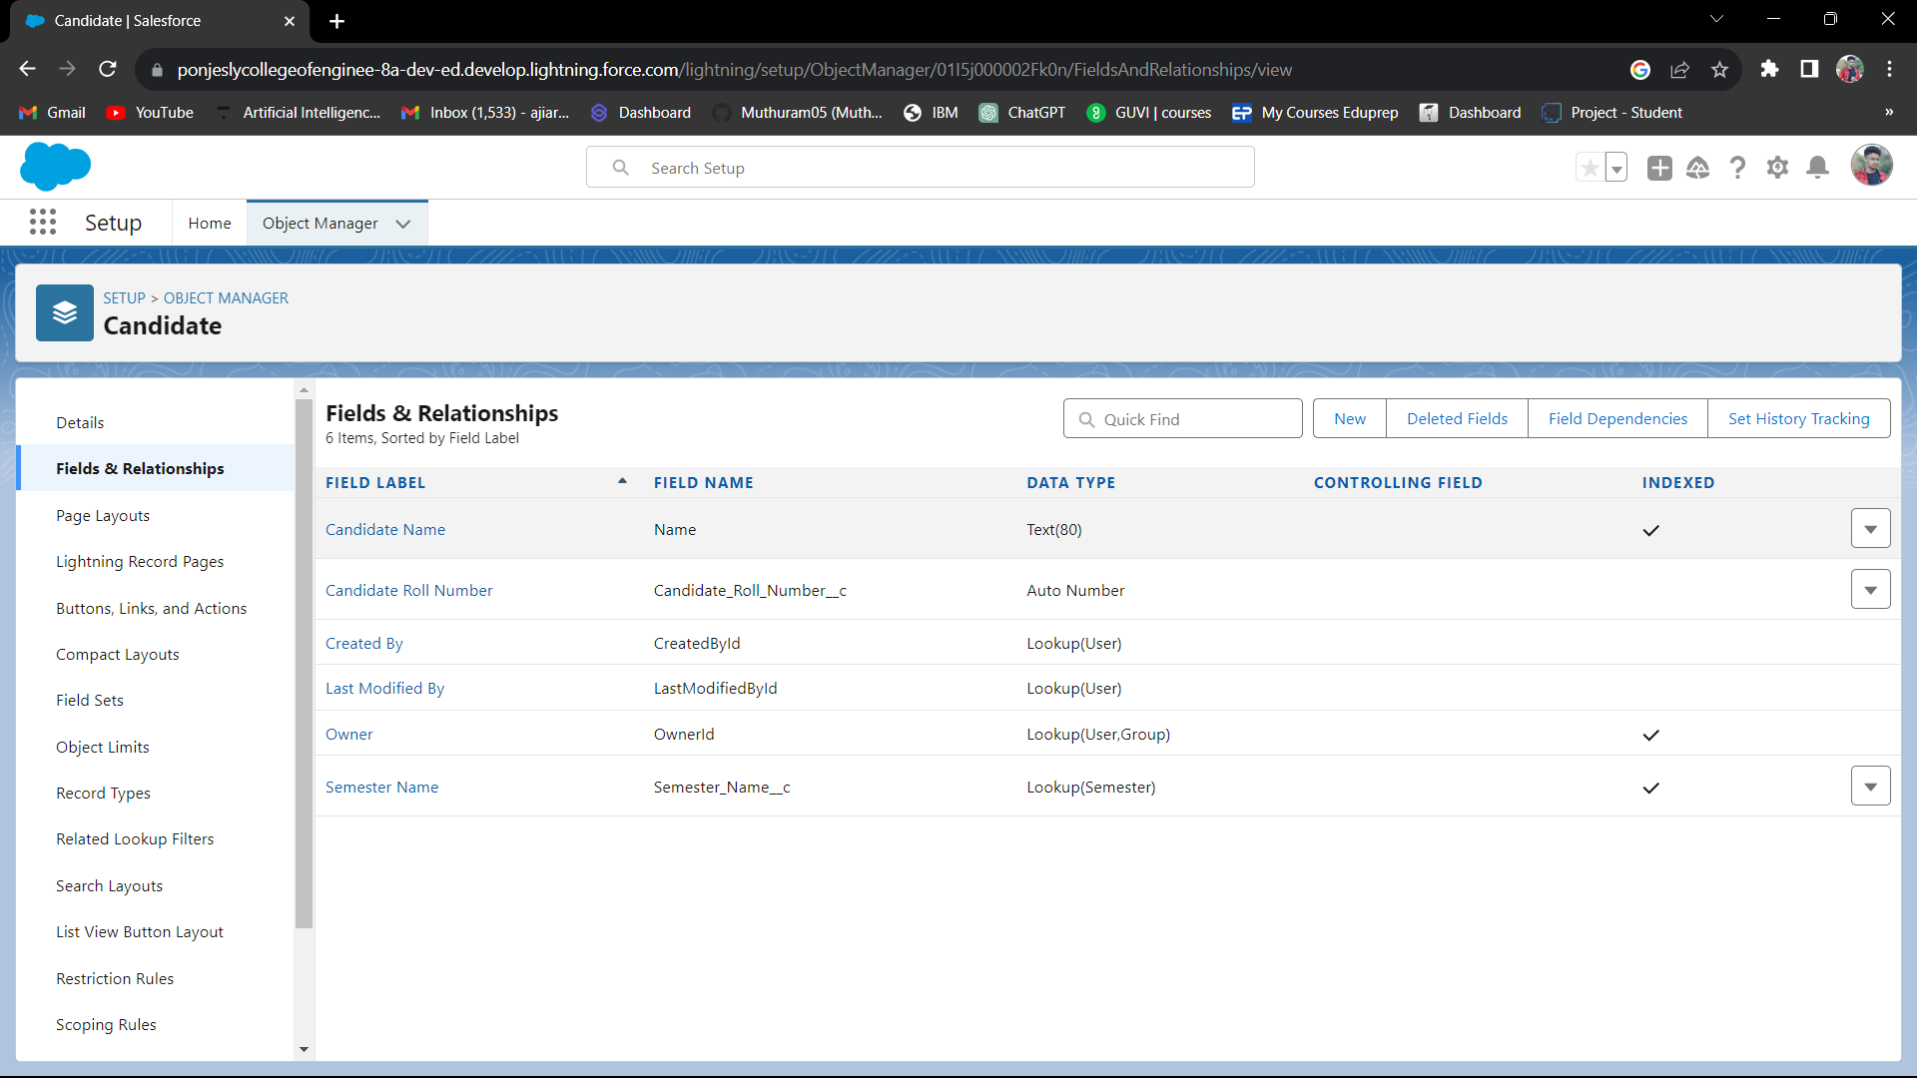

Course and Lecturer Relationships

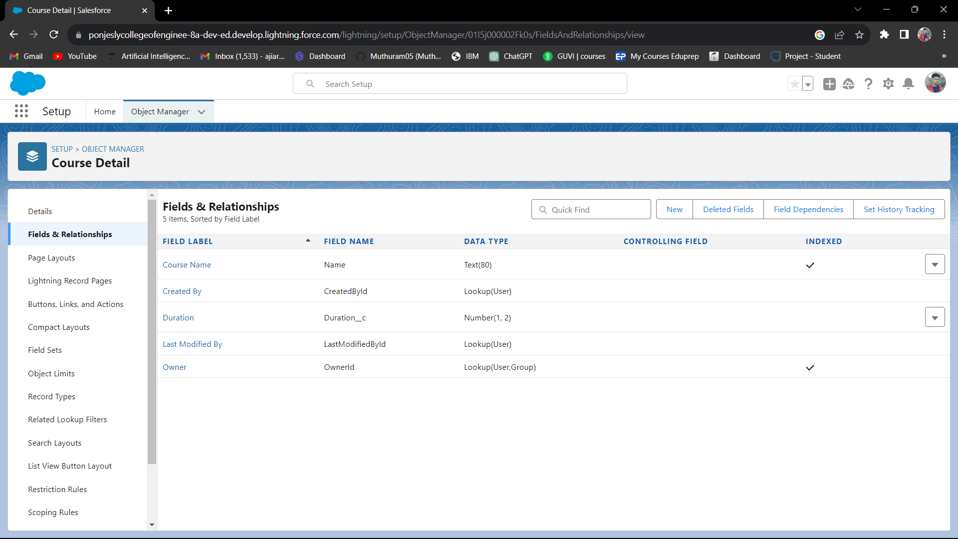

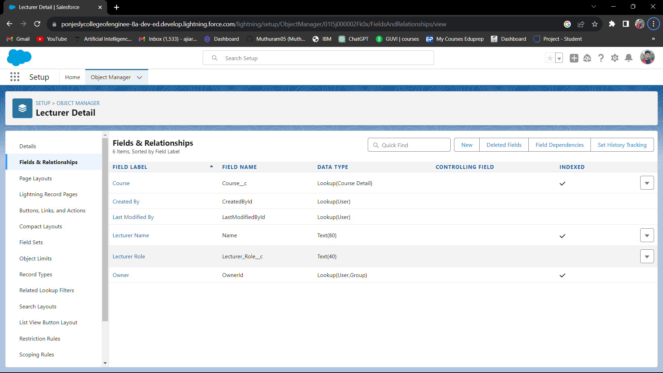

**Creating Custom Tabs:**

(eg. Semester, Candidate)

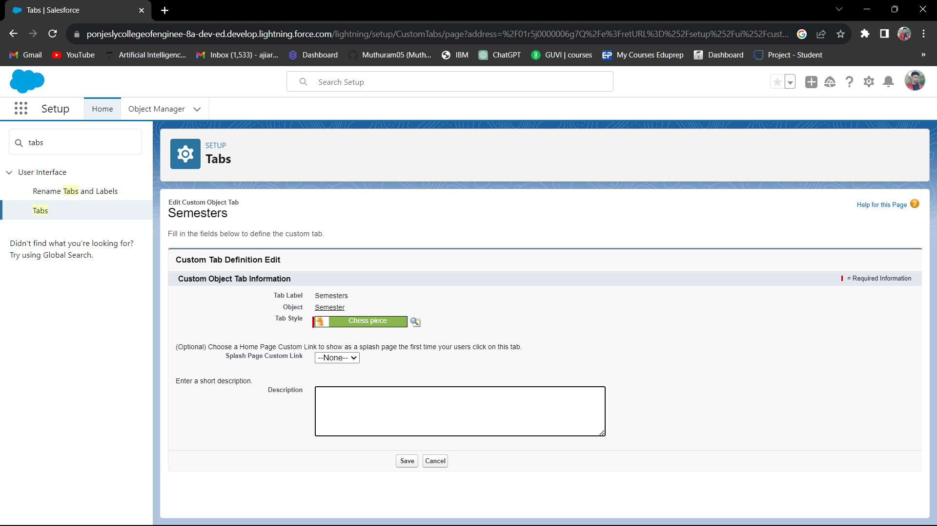

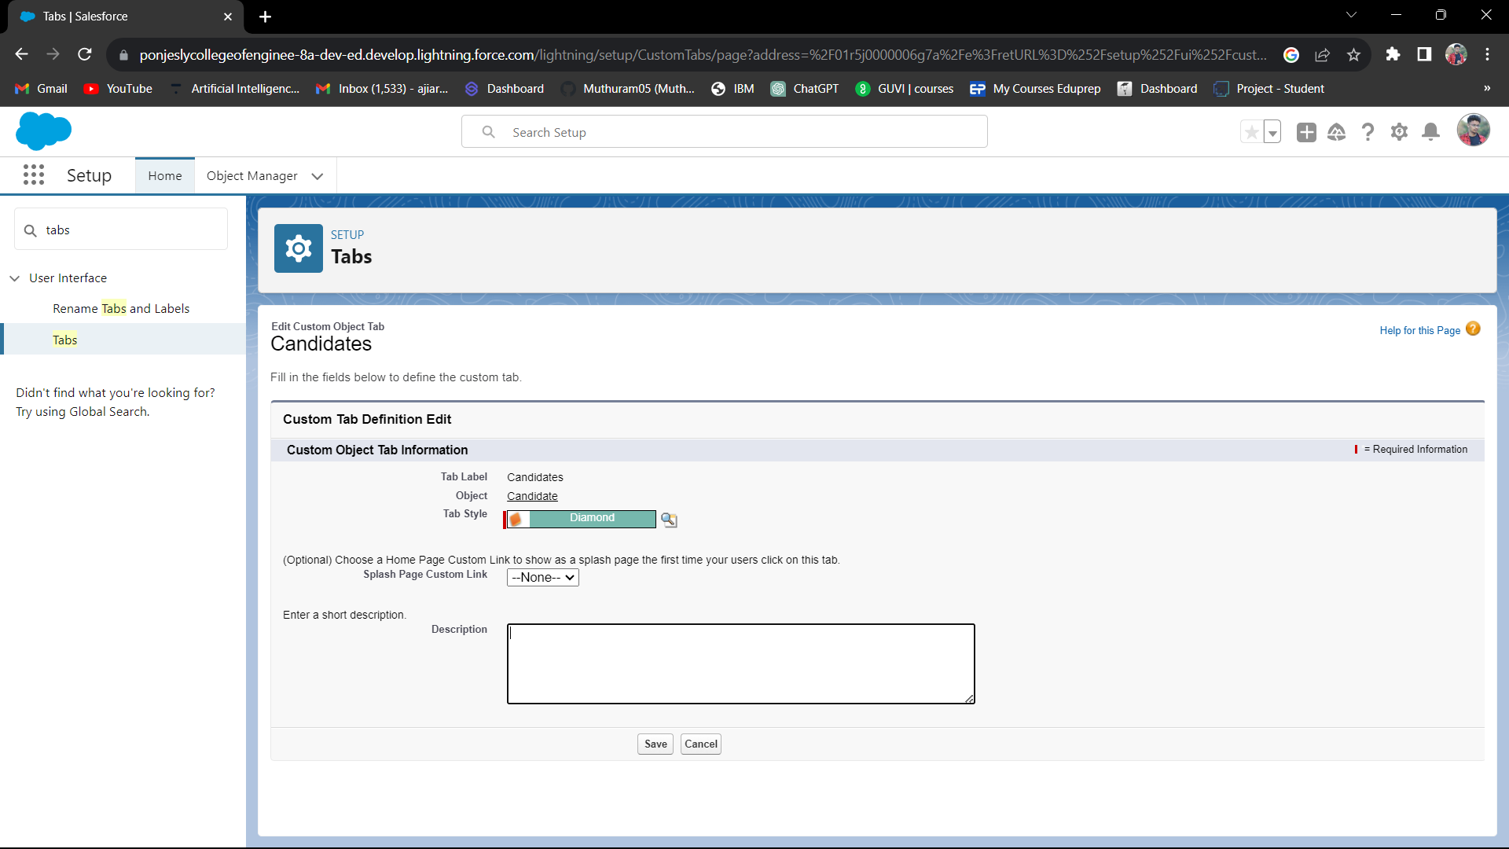



**Creating Lightning App**

Candidate Internal Result Card

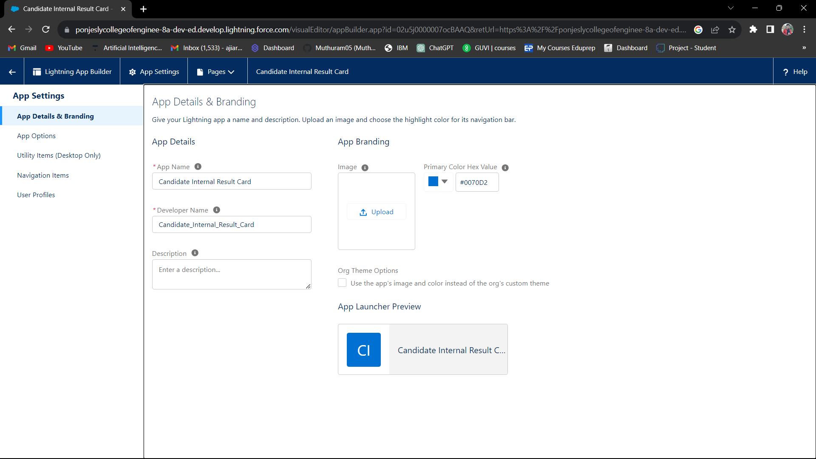

**Task 3**

**Users & Data Security:**

[Working of security systems like profiles and users]

User 1 [Aji Kumar]

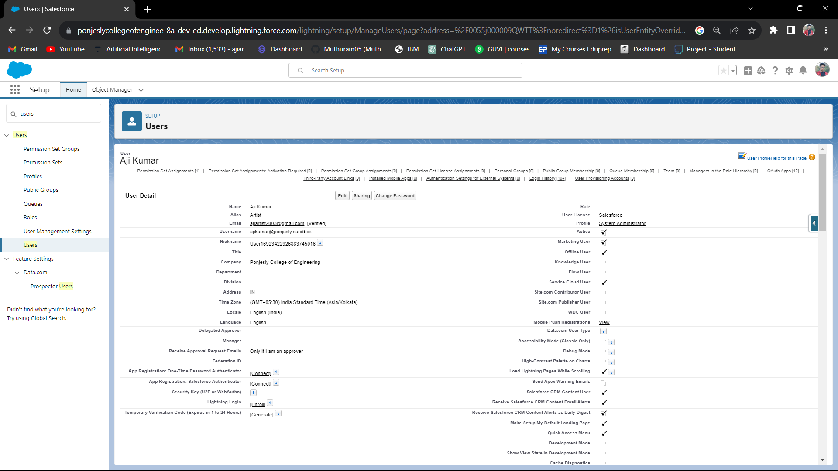



User 2 [ Class Teacher]

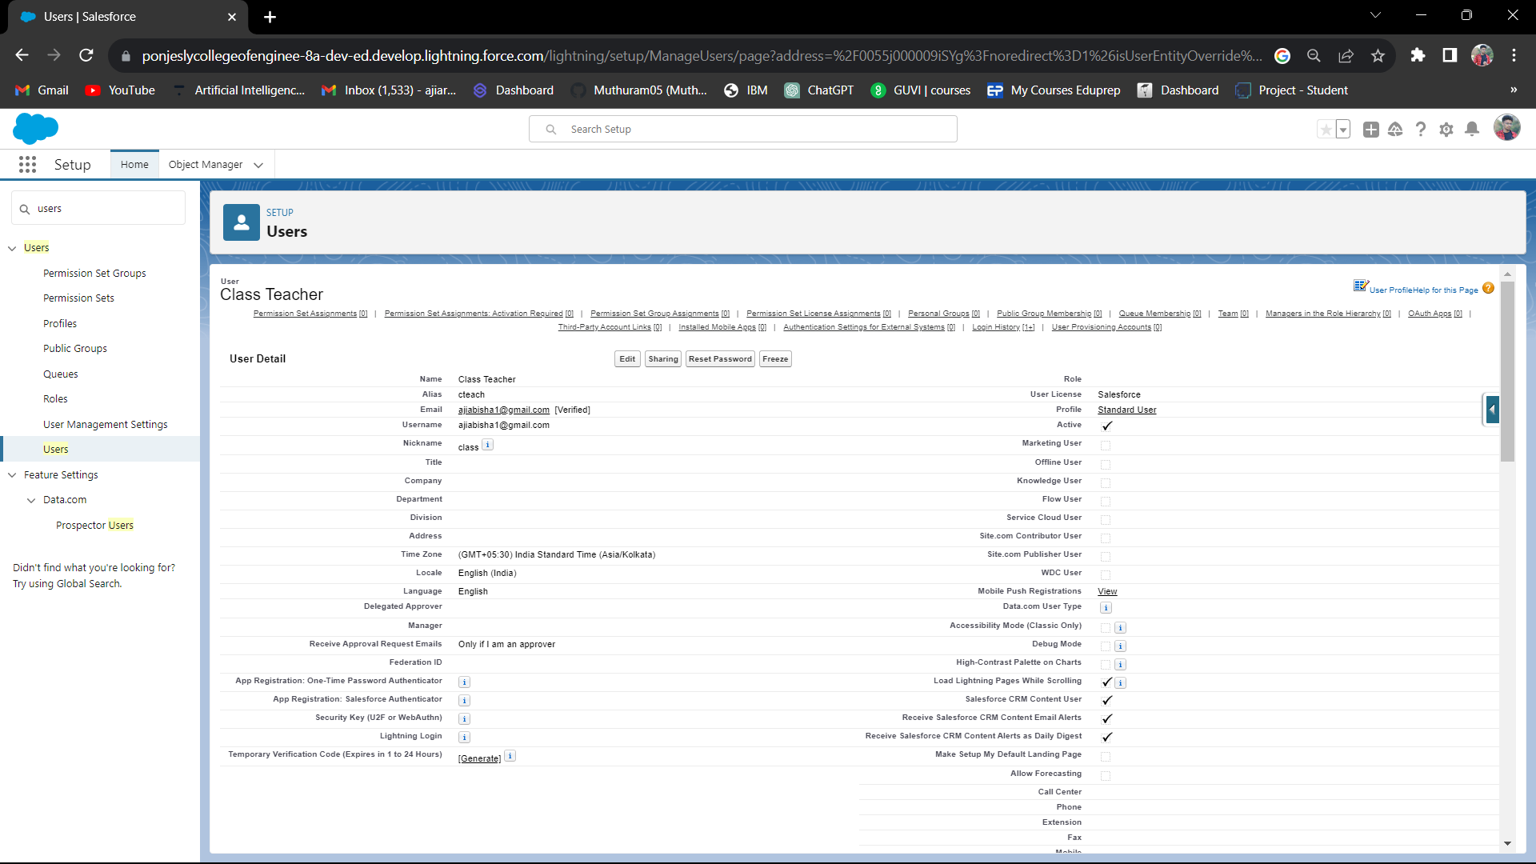



Sharing Rules:

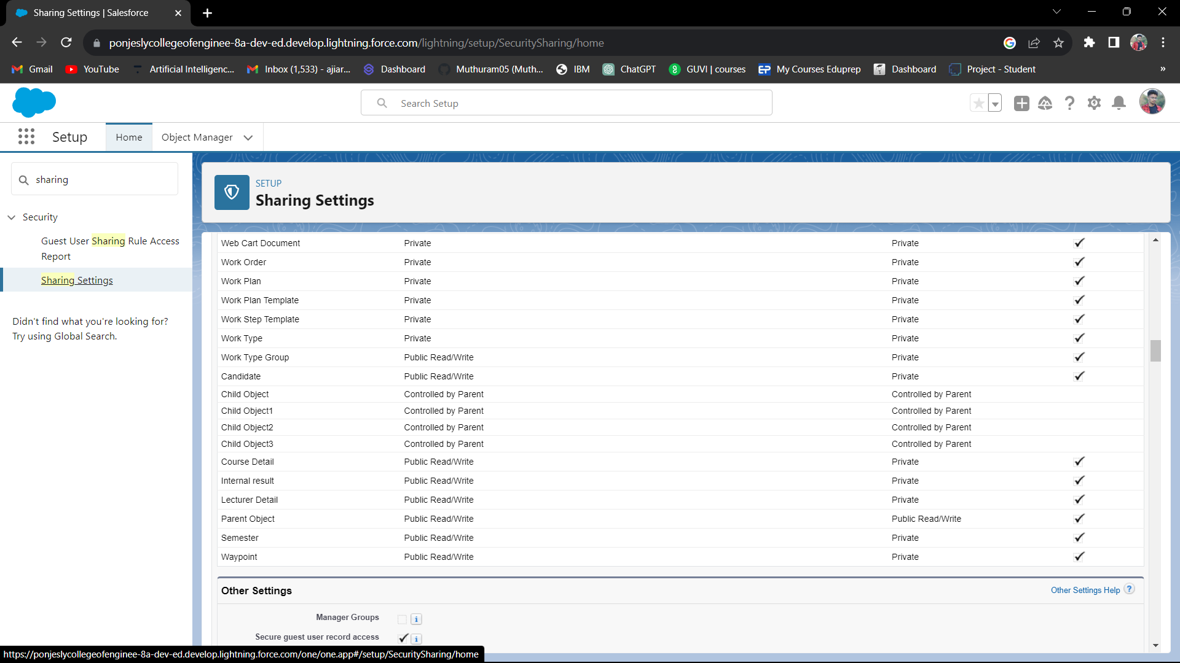

Security Level Utilities for the Object and Record Levels

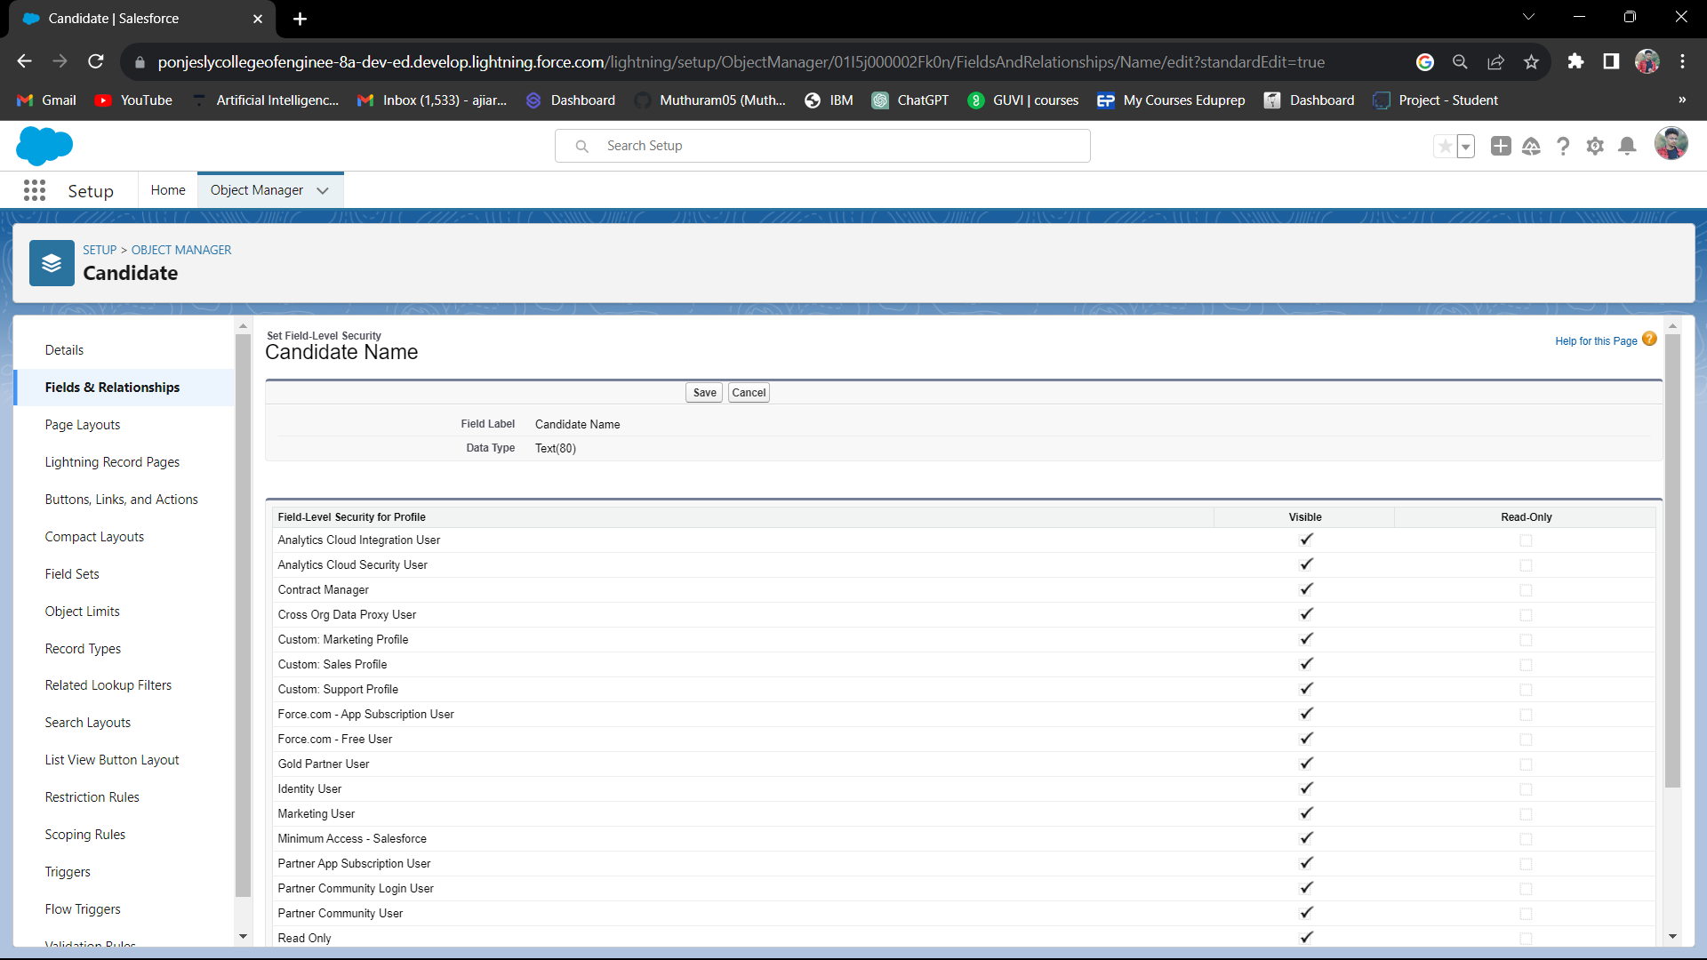

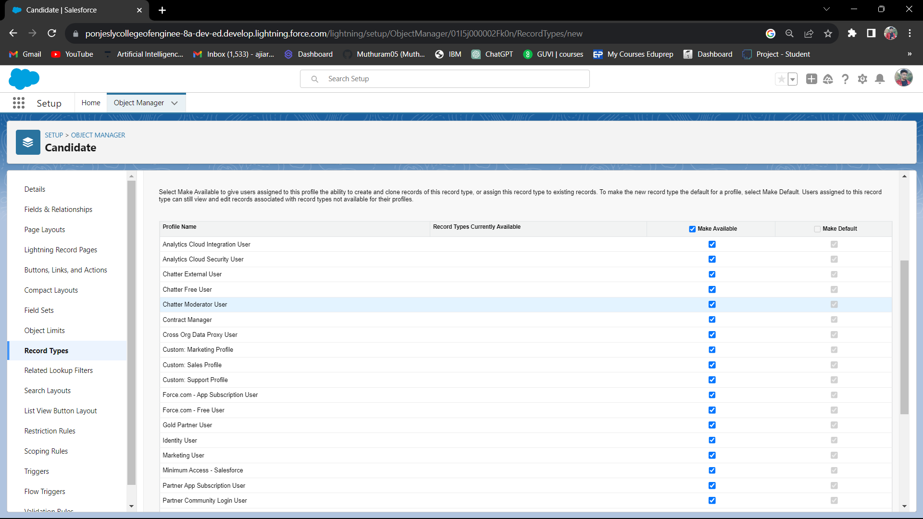

**Task 4**

**Automation**

[Working on automation tools like trigger and flows]

Creating Screen Flow

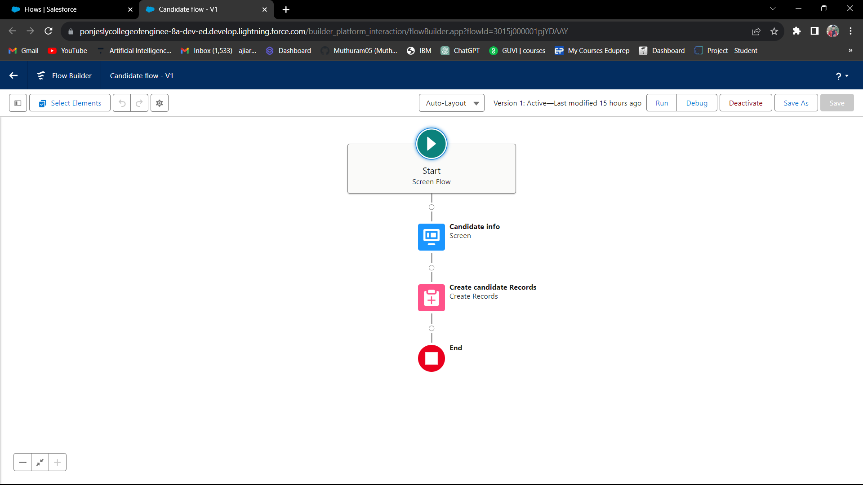

Creating App Page

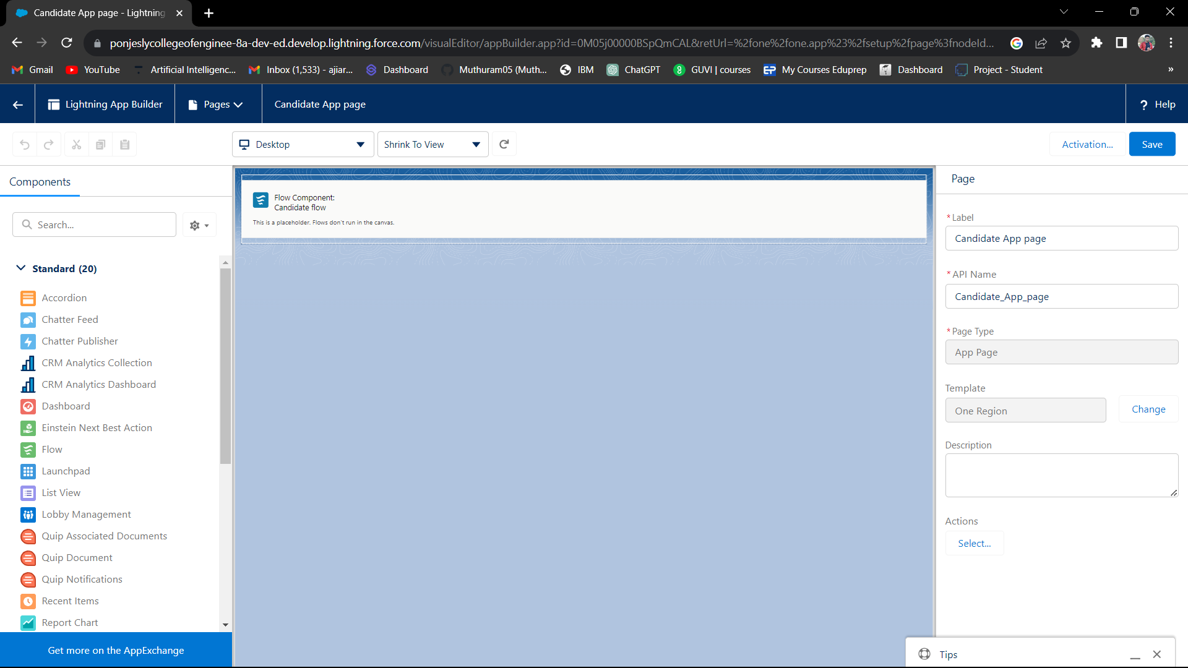

Creating Apex Classes

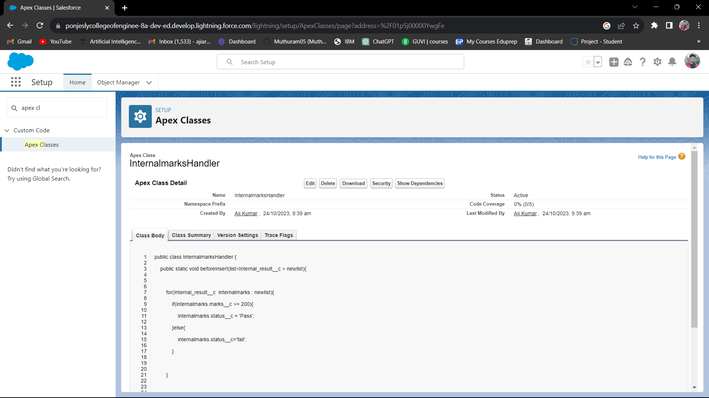

Creating Apex Triggers

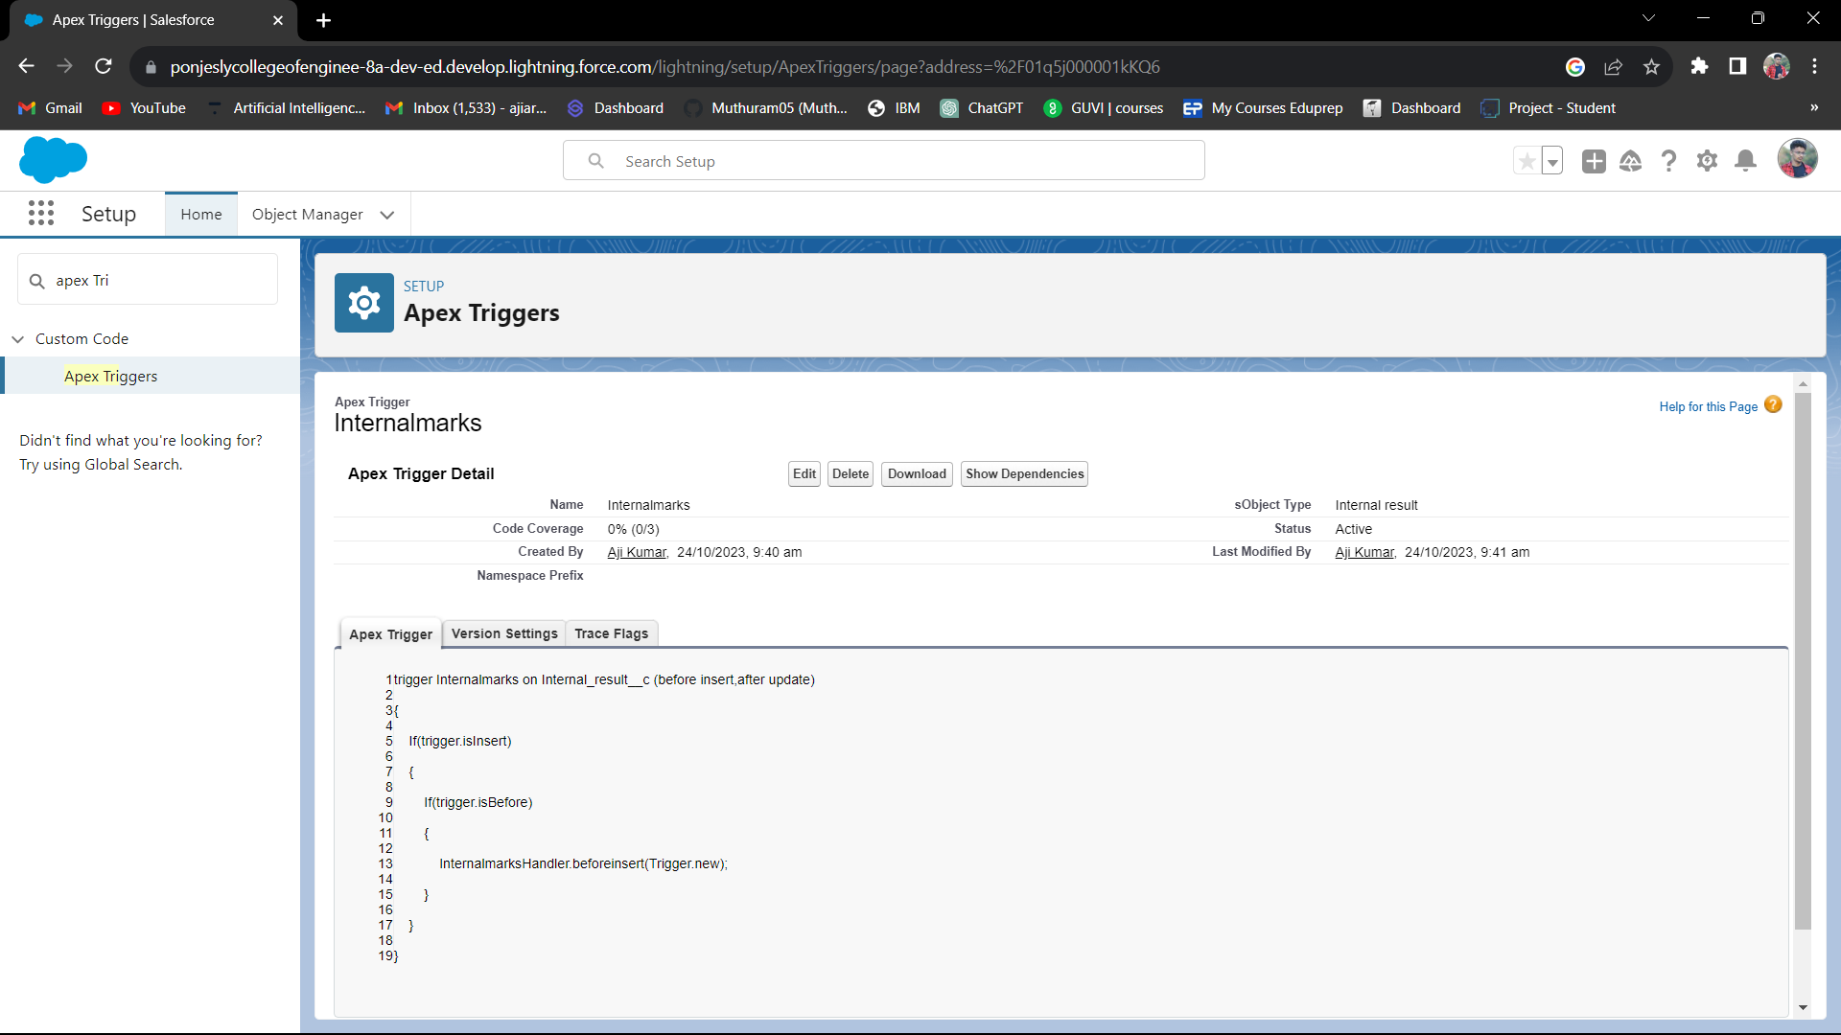

**Task 5**

**Reports and Dashboards**

[Analyze the data and represent them in a pictorial way]

Candidate Page

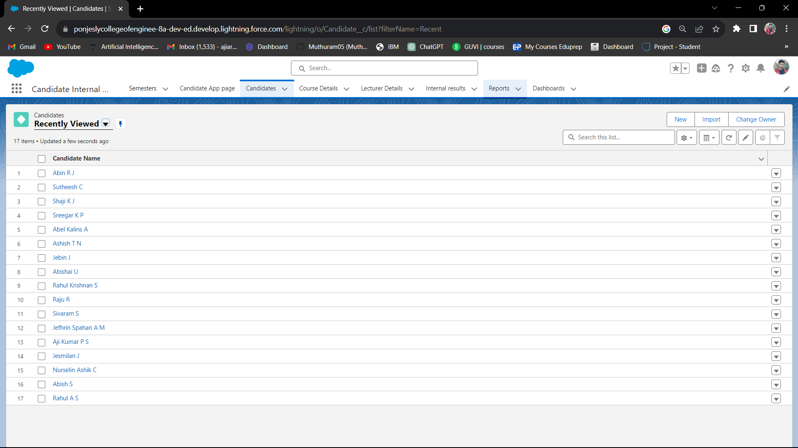

Report for Candidate Internal Result

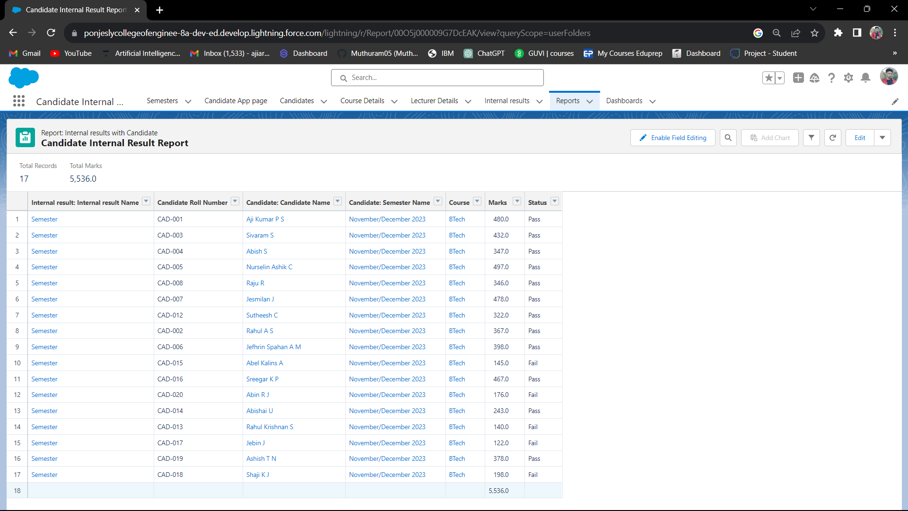

Report for Semester with Course

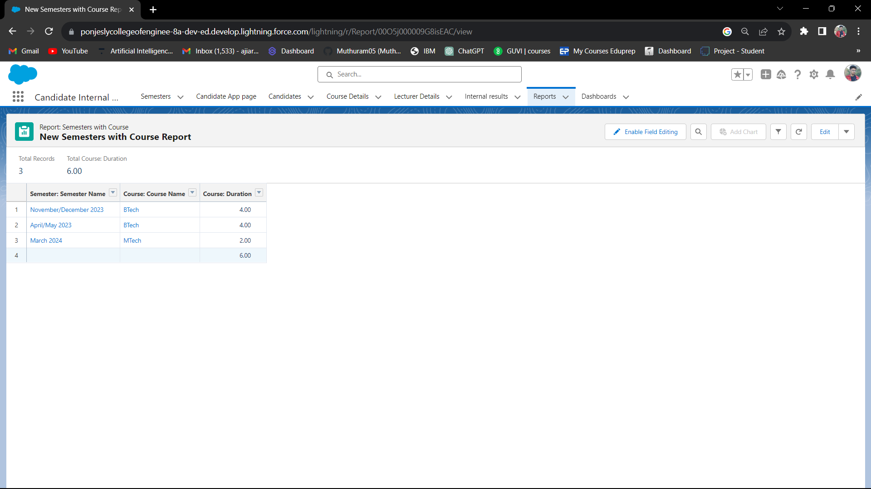

Dashboard for Candidate Internal Result

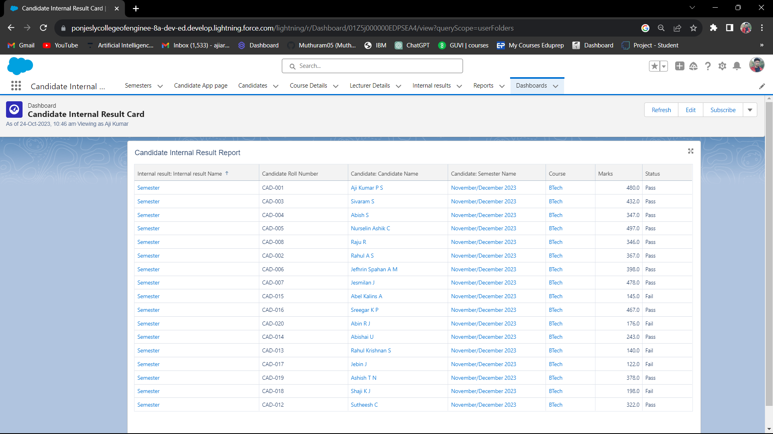

Dashboard for Semester with Course

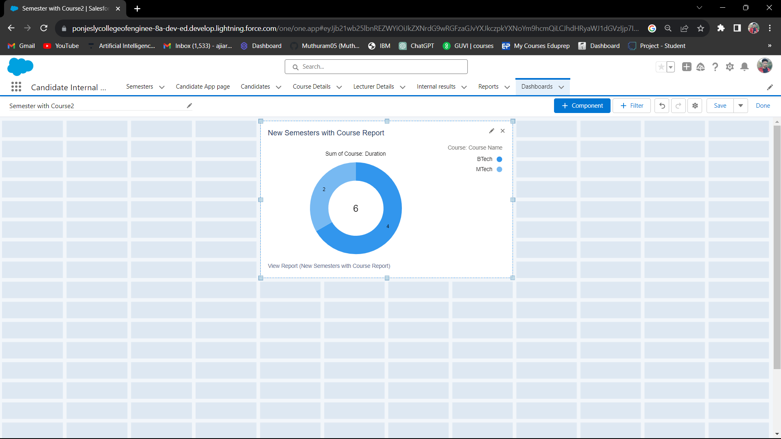

**Task 6**

**Project Demonstration**

[Able to convey the need of creating an app]

Demo Video Link:

<https://drive.google.com/file/d/1V4ZXN5xmRM5ie06EhHolGPWU5yPqM9LO/view?usp=drive_link>

Trailhead Url:

Team Leader: Aji Kumar P S

<https://www.salesforce.com/trailblazer/ajikumar>

Team Member1: Rahul A S

<https://www.salesforce.com/trailblazer/rahulas>

Team Member2: Abish S

<https://www.salesforce.com/trailblazer/abishs>

Team Member3: Shaji K J

<https://www.salesforce.com/trailblazer/shajikj>